Name | Gap Ryol Lee | 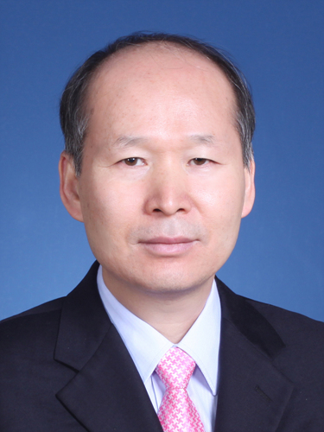
Affiliation | Sogang University
Official Position | Professor
Education | 1991 - 1997 : PhD, Molecular Biology, Seoul National University  1989 -1991 : MS, Zoology, Seoul National University  1985 -1989 : BS, Zoology, Seoul National University
Major Career  (less than  5 items) | 2006 – present : Professor, Department of Life Science, Sogang University  2003 – 2006 : Associate Research Scientist, Yale University School of Medicine,  Section of Immunobiology  1997 – 2003 : Postdoctoral fellow, Yale University School of Medicine,  Section of Immunobiology
Biography
Gap Ryol Lee received his Ph.D. in Molecular Biology in 1997 from Seoul National University and then conducted postdoctoral training at the Department of Immunobiology at Yale University. He joined the Department of Life Science at Sogang University in 2006 as an assistant professor, and now he is a full professor in the department. During his career, he studied molecular mechanism of Th2 cytokine gene regulation and discovered locus control region in the Th2 cytokine locus, and he is currently studying differentiation and function of CD4 T cells.

* Please note that your Reply Form & Photo might be uploaded at KAI International Meeting 2020 website.

