Name | Ho-Keun Kwon | 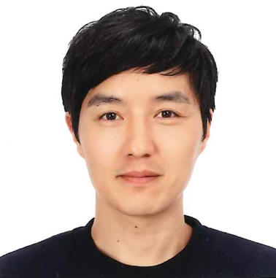
Affiliation | Department of Microbiology and Immunology, Yonsei University College of Medicine
Official Position | Assistant professor
Education | 2011: Ph.D at GIST mentored by Dr. Sin-Hyeog Im
Major Career  (less than  5 items) | 2011-2016: Post-doc at Harvard Medical School mentored by Dr. Christophe Benoist & Diane Mathis  2017-2018: Research associate at Harvard Medical School mentored by Dr. Jun Huh  2019-present: Assistant Professor, Department of Microbiology and Immunology, Yonsei University College of Medicine
Biography
Ho-Keun Kwon is an assistant professor in the Department of Microbiology and Immunology, Yonsei University College of Medicine at Yonsei University. He received his Ph.D. degree in the laboratory of Dr. Sin-Hyeog Im at GIST. He completed his post-doctoral training in the laboratory of Dr. Christophe Benoist & Diane Mathis for Tregs biology at Harvard Medical School and continued to investigate ‘Neuro-Immune interaction’ field as the research associate in the laboratory of Dr. Jun Huh. Currently, his research is mainly focusing on the ‘Gut-Immune-Brain communication’ in various pathophysiological contexts.

* Please note that your Reply Form & Photo might be uploaded at KAI International Meeting 2020 website

