Name | Jun Cho | 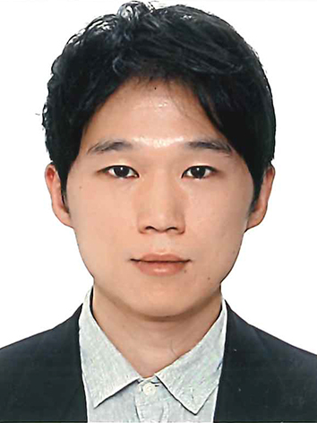
Affiliation | Department of Biomedical Science & Engineering  Gwangju Institute of Science & Technology
Official Position | Assistant professor
Education | 2008-2013 Ph.D. in Biological Sciences, Seoul National University, Seoul, Republic of Korea  2002-2007 B. Sc. in Biological Sciences, Seoul National University, Seoul, Republic of Korea
Major Career  (less than  5 items) | 2019-present Assistant professor, Gwangju Institute of Science and Technology, Gwangju, Republic of Korea  2015-2019 Post-doctoral fellow, Department of Microbiology and Immunology, Harvard Medical School, United States  2013-2015 Post-doctoral fellow, Centre for RNA Research, Institute for Basic Science at Seoul National University, Republic of Korea
Biography
I am multi-disciplinary researcher, especially working on RNA biology and immunology research. I received Ph.D. degree at Seoul National University under the supervision of Prof. V. Narry Kim. During my graduate course, I studied unknown molecular actions of an RNA binding protein, LIN28A, one of the pivotal factors to determine the pluripotency of stem cells. After my graduation, I collaborated with Prof. Bongiun Kaang’s neuroscience group at Seoul National University to elucidate translational controls in a nervous tissue during long-term memory formation. More recently, I stepped in immunological research, especially working on the development and accumulation of regulatory T cells in peripheral tissues under the mentorship of Prof. Diane Mathis at Harvard Medical School. Currently, I am running my own research group as a faculty at Gwangju Institute of Science & Technology. We are focusing on post-transcriptional regulation in the immune system.

* Please note that your Reply Form & Photo might be uploaded at KAI International Meeting 2020 website.

