Name | Kyungho Choi | 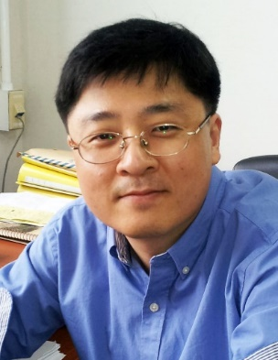
Affiliation | Seoul National University College of Medicine
Official Position | Associate Professor
Education | 1996-1998 Ph.D. Department of Biochemistry, Seoul National University College of Medicine, Seoul, Korea  1994-1996 M.S. Department of Biochemistry, Seoul National University College of Medicine, Seoul, Korea  1988-1994 M.D. Seoul National University College of Medicine, Seoul, Korea
Major Career  (less than  5 items) | 2012. 09. – present Associate Professor  Department of Biochemistry and Molecular Biology  Seoul National University College of Medicine, Korea  2005. 10. – 2012. 08. Senior Scientist  Specific Organs Cancer branch, Research Institute  National cancer center, Korea  2001. 05. – 2005. 09. Visiting Fellow  Laboratory of Cellular and Molecular Immunology,  NIAID, NIH, USA
Biography
Kyungho Choi MD, PhD is a molecular immunologist and an Associate Professor at the Department of Biochemistry and Molecular Biology, Seoul National University College of Medicine, Korea. He received his MD from Seoul National University College of Medicine in 1994 and his PhD from the Department of Biochemistry and Molecular Biology of the same college in 1998. He developed his career as an immunologist when he worked as a postdoctoral fellow in Dr. Ron Schwartz's laboratory (Laboratory of Cellular and Molecular Immunology) at NIH, USA from 2001 to 2005. After moving back to Korea in 2005, he joined the Research Institute National Cancer Center as a Senior Scientist. In 2012, he moved to his current position at the Seoul National University. His current research focuses on molecular mechanism of T cell tolerance and its application to cancer immunotherapy and treatment of autoimmune diseases.

* Please note that your Reply Form & Photo might be uploaded at KAI International Meeting 2020 website.

