Name | Min-Soo Kim | 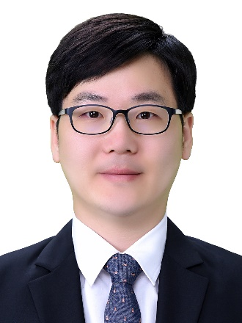
Affiliation | Department of Microbiology and Molecular Biology in Chungnam National University
Official Position | Assistant professor
Education | Ph.D.: Department of Life and Nanopharmaceutical Sciences, Kyung Hee University (2015)  M.S.: Green Chemistry and Biology, University of Science and Technology (2010)  B.S.: Department of Life Science, Gyeongsang National University (2008)
Major Career  (less than  5 items) | 2015-2018: Research Professor, Department of Biology, Kyung Hee University  2018-present: Assistant Professor, Department of Microbiology and Molecular Biology, Chungnam National University
1. Min-Soo Kim§, Yoonhee Kim§, Hyunjung Choi§, Woojin Kim, Sumyung Park, Dongjoon Lee, Dong Kyu Kim, Haeng Jun Kim, Hayoung Choi, Dong-Wook Hyun, June-Young Lee, Eun Young Choi, Dong-Sup Lee, Jin-Woo Bae, Inhee Mook-Jung (2020) Transfer of a healthy microbiota reduces amyloid and tau pathology in an Alzheimer's disease animal model. GUT 69(2):283-294 (§co-first authors)

2. Min-Soo Kim and Jin-Woo Bae (2018) Lysogeny is prevalent and widely distributed in the murine gut microbiota. ISME J. 12(4):1127-1141

3. Min-Soo Kim and Jin-Woo Bae (2016) Spatial disturbances in altered mucosal and luminal gut viromes of diet-induced obese mice. Environ. Microbiol. 18(5):1498-1510

4. Jin-Young Yang§, Min-Soo Kim§, Eugene Kim§, Jae Hee Cheon§, Yong-Soo Lee, Sang-Uk Seo, Su-Hyun Lee, Yeji Kim, Seung-Ho Shin, Sun Shim Choi, Bumseok Kim, Sun-Young Chang, Hyun-Jeong Ko, Jin-Woo Bae, and Mi-Na Kweon (2016) Enteric viruses ameliorate gut inflammation via the TLR3 and TLR7-mediated interferon-β production. Immunity. 44(4):889-900 (§co-first authors)

* Please note that your Reply Form & Photo might be uploaded at KAI International Meeting 2020 website.

