Name | Onur BOYMAN | 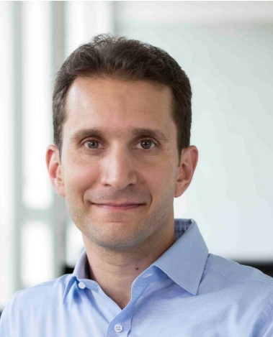
Affiliation | University of Zurich (UZH) and Department of Immunology, University Hospital Zurich (USZ)
Official Position | Professor and Chair of Clinical Immunology, UZH  Director, Department of Immunology, USZ
Education | Medical School, UZH
Major Career  (less than  5 items) | Since 2014: Professor and Chair of Clinical Immunology, UZH, and Director, Department of Immunology, USZ  2010–2014: Swiss National Science Foundation (SNSF) Assistant Professor, UZH, and Senior Consultant Physician, Allergy Unit, USZ  2006–2010: Resident and Principal Investigator, Division of Immunology and Allergy, Department of Medicine, University Hospital Lausanne  2003–2006: Postdoctoral Fellow, Department of Immunology, The Scripps Research Institute, La Jolla, CA, USA.  2001–2003: Resident and Research Fellow, Department of Dermatology, USZ
After obtaining his M.D. degree from the University of Zurich, Switzerland, Onur Boyman trained as a postdoctoral fellow at the Scripps Research Institute in La Jolla, California. He then joined the Division of Immunology and Allergology of the University Hospital of Lausanne, Switzerland, as principle investigator and clinical fellow, before receiving in 2010 a professorship of the Swiss National Science Foundation. Since 2014, Onur Boyman has been Professor and Chair of Clinical Immunology at the University of Zurich and Director of the Department of Immunology at University Hospital Zurich. Research in his laboratory focuses on the modulation of immune responses, with a particular interest in cytokines and cytokine-directed approaches. Boyman and colleagues discovered, characterized and developed interleukin-2 (IL-2)/anti-IL-2 antibody complexes, thus opening the field of biased IL-2 immunotherapy. For his achievements, he received, among others, the Georg Friedrich Goetz Prize of University of Zurich in 2011, the Gold Prize of LEO Pharma Research Foundation in 2013, and the Pfizer Research Prize in 2018. Onur Boyman's research has resulted in more than 82 publications in leading journals of the field, including in Science, Science Translational Medicine, Nature, and Cell, as well as in ten patent applications, of which four have been licensed out to companies. He also co-founded two biotech companies.

