[Reply Form_ Curriculum Vitae]

Name | Sin-Hyeog Im, Ph.D. | 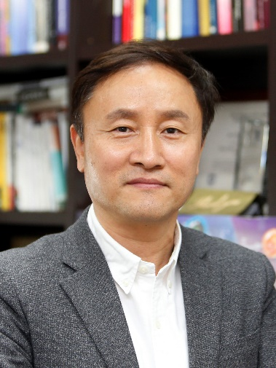
Affiliation | Department of Life Sciences, POSTECH
Official Position | Professor
Education | 1987. Bsc. Korea University (Seoul, Korea)  1989. MSc. Korea University (Seoul, Korea)  2001. Ph.D. Weizmann Institute of Science (Rehovot, Israel)
Major Career  (less than  5 items) | 1991-1996: Senior Scientist, R&D Center, Chong Kun Dang Co. Korea  2001-2003: Postdoc Fellow, Harvard Medical School, Boston, USA  2004-2014.02: Professor, Gwangju Institute of Science and Technology, Korea.  2014-2018. Group leader, Acting Director, Institute for Basic Science (IBS), Korea  2014.03- Present. Professor, POSTECH, Korea  2019.06- CEO, ImmunoBiome Inc. Korea
Dr. Sin-Hyeog Im is a professor in the department of Life Sciences, Pohang University of Science and Technology (POSTECH). Since establishing his own lab in 2004, he has been working on the cellular and molecular mechanisms of immune tolerance in health and disease. He has investigated the role of commensal microbiota in shaping host immunity. He believes that targeting gut immunity by rationally selected microorganism could remold the dysregulated immune responses in diverse immune disorders. Initially he identified anti-inflammatory probiotic bacteria that induces high levels of IL-10 and immunoregulatory T cells (Treg) to suppress inflammatory immune responses. A probiotic consortium composed of 5 different strains (IRT5) could induce Treg cells in dendritic cell (DC) dependent manner, then migrate to the site of inflammation, and addressed the importance of gut microbiota in immune disorders [PNAS (2010). This paper has been highly cited (506 times) and recognized as cutting-edge paper in probiotic research. To further defined effector molecules at the molecular levels, he moved to POSTECH in 2014. Using the germ-free mouse facility, he further proved that Bifidobacterium bifidum PRI1 could induce Treg cells in the colon, and defined the Treg inducing molecules. He proved that cell surface derived beta-glucan/galactan containing polysaccharides (CSGG) could induce diverse antigen-specific Treg cells, and paved a way to develop bacteria as a potential immune-modulatory drug (microbiome therapeutics) (Science Immunology, 2018). Recently his team also identified immune-stimulatory bacteria that shows potent anti-cancer activity and further defined the capsular polysaccharides as the key effector. At the molecular level, he Identified ID2 (Nature Comms. 2018) and Tph1 (unpublished) as key players in controlling plasticity and function of Treg cells in autoimmunity and cancer. Moreover, he has investigated how a single faulty gene, Ets1, can lead to Lupus development. He reported that Ets1 is involved in controlling the expansion of a newly-described class of immune cells, known as T follicular helper type 2 (Tfh2) cells that produce pathogenic autoantibodies in mice and human SLE cases. Moreover, he also suggested that blocking of autoantibody production pathway could mitigate some SLE features emphasizing the need for alternative strategies targeting Tfh2 cells for lupus treatment (Immunity. 2018). Collectively, Dr. Im’s research will provide a close link between basic science and translational approach to treat hyper-immune responses such as autoimmune and allergic disorders.

* Please note that your Reply Form & Photo might be uploaded at KAI International Meeting 2020 website.

