Name | Su-Hyung Park | 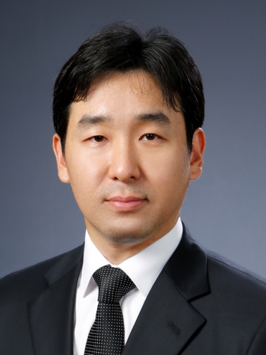  Photo
Affiliation | Graduate School of Medical Science and Engineering, KAIST
Official Position | Associate Professor
Education | 2003.8 – 2008.2 Ph.D. Division of Molecular and Life Science, POSTECH  2001.3 – 2003.8 M.S. Division of Molecular and Life Science, POSTECH  1997.3 – 2001.2 B.S. Department of Life Science, POSTECH
Major Career  (less than  5 items) | 2019.3 – present Associate Professor, Graduate School of Medical Science and Engineering, KAIST  2014.10 – 2019.2 Assistant Professor, Graduate School of Medical Science and Engineering, KAIST  2008.9 – 2014.9 Postdoctoral Fellow / Research Fellow, National Institutes of Health (NIH), USA
Biography

Su-Hyung Park received his Ph.D from Pohang University of Science and Technology (Korea), and then did his postdoctoral training at National Institutes of Health (USA). He is currently an associate professor at Graduate School of Medical Science and Engineering, KAIST, Daejeon (Korea). His laboratory, the Laboratory of Translational Immunology and Vaccinology, focuses on the research of immune responses and immunopathogenesis in viral infections and cancers.

* Please note that your Reply Form & Photo might be uploaded at KAI International Meeting 2020 website.

