Name | YOUN SOO CHOI, Ph.D. | 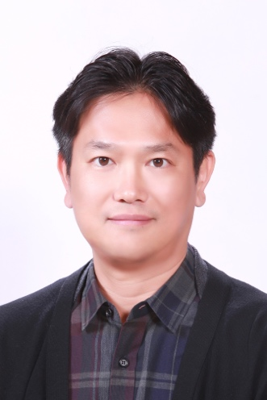
Affiliation | Seoul National University College of Medicine
Official Position | Associate Professor
Education | Korea University B.S. 2001  University of California, Davis Ph.D. 2008
Major Career  (less than  5 items) | Associate Professor, Seoul National University College of Medicine, 2015 ~  Instructor, La Jolla Institute of Allergy and Immunology, 2014 – 2015  Post-doctoral fellow, La Jolla Institute of Allergy and Immunology, 2009 – 2015  Post-doctoral fellow, University of California, Davis, 2008 – 2009
Dr. Choi received B.S. degree at Korea University in 2001 and Ph.D. degree at University of California, Davis in 2008 under supervision of Dr. Nicole Baumgarth. He then joined Dr. Shane Crotty’s laboratory as a postdoctoral fellow in 2009 to study the regulation of follicular helper T cell differentiation. Dr. Choi runs his own laboratory at Seoul National University College of Medicine from 2015 with research interests including the mechanisms regulating crosstalk between B cells and CD4 T cells and humoral immune responses.

* Please note that your Reply Form & Photo might be uploaded at KAI International Meeting 2020 website.

