Name | Yoon Seok Choi | 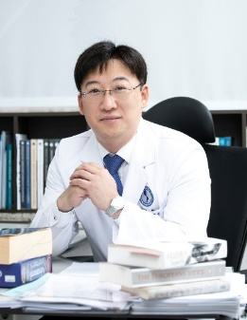
Affiliation | Department of Hematology-Oncology,  Ajou University School of Medicine
Official Position | Associate Professor
Education | 2003. M.D. Korea University College of Medicine, Seoul, Republic of Korea  2013. Ph.D. in human T cell immunology. Graduate School of Medical Science and Engineering, KAIST, Daejeon, Republic of Korea
Major Career  (less than  5 items) | 2020-present Associate Professor, Department of Hematology-Oncology, Ajou University School of Medicine, Suwon, Republic of Korea  2013-2020 Clinical Instructor and Assistant Professor, Department of Internal Medicine, Chungnam National University College of Medicine, Daejeon, Republic of Korea  2008-2013 Specialized Research Associate, Graduate School of Medical Science and Engineering, KAIST, Daejeon, Republic of Korea  2004-2008 Residency in Department of Internal Medicine, Korea University Medical Center, Seoul, Republic of Korea
Biography
Dr. Yoon Seok Choi is a physician-scientist (M.D., Ph.D.) who is working on T cell immunology in the setting of various hematologic malignancies. As a translational researcher, he mainly focuses on functional characterization of tumor-specific T cells in multiple myeloma and malignant lymphoma. In particular, he has been tried to identify a novel therapeutic approach to overcome immunosuppressive microenvironment of multiple myeloma and to booster anti-tumor activity of tumor-specific T cells. He also has interest in the plasticity of regulatory T cells in pathologic conditions associated with immune-mediated tissue damage, including human acute and chronic graft-versus-host disease after allogeneic hematopoietic stem cell transplantation. In addition, as a clinical hematologist/oncologist, he is leading and participating in many clinical trials in the field of hematologic malignancies and hematopoietic stem cell transplantation.

* Please note that your Reply Form & Photo might be uploaded at KAI International Meeting 2020 website.

